New Student Laptop Program
2024
Information Technology Department
Swan Hill College
1/1/2024
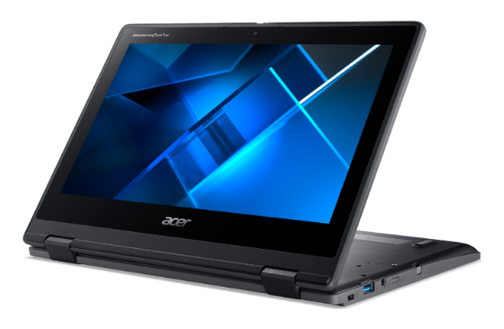
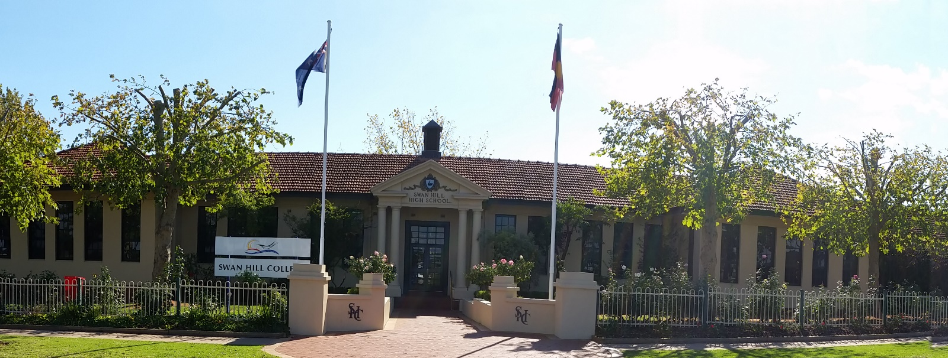
Netbook Agreement for Parents and Students.

(Information Pack Version 01-01-2024.1)

This information sheet is to be viewed in addition to the following Swan Hill College Policies and Documents:-

- Year 7 ICT 101 course (Part of the College Educational Program)
- Student Computer and Network policy (In Parent Handbook)

Parents will be supplied with a copy of this agreement, acceptable use policies and the netbook agreement.

- Additionally, the College will supply Headphones to Year 7 and Year 9 students when they sit their NAPLAN test.

Receiving your Device.
Devices ordered from the College portal before the end of November will be ready for pick up by Christmas.

Devices that miss the Christmas delivery will be held by the College and then distributed to your child at school on January 31st 2024 if a signed Acceptable Usage Agreement is returned to the College.

Ownership of the Device.
The device remains the property of the parent. Parents should ensure that the device is covered by either the Portal Insurance, or listed on their own personal insurance policies.

Taking care of your device.
Students are responsible for the general care of the device that they use at the College. Devices that are broken or fail to work properly must be taken to the College ICT Office for repair and or initiation of insurance procedures.
Devices will be collected randomly throughout the year for a “Health Checkup”. During this checkup, security software updates and other software updates will be loaded by the Swan Hill College ICT technicians. An appraisal of the physical condition and use of the device will also be made.

General Precautions.
- Food and Beverages can damage the device. Do not expose the device to food or drinks.
- Cords, cables and SD cards should be inserted and removed carefully.
- Devices should never be carried holding the screen.
- Devices should remain free of any writing or drawing.
- The device should never be left in an unattended vehicle or unsupervised area.
- Students are responsible for ensuring the device is fully charged before school each day.
Screen Care.
- Do not lean on top of the device when it is closed.
- Do not poke the screen with any object other than the supplied stylus.
- Check the keyboard before closing the lid. No pens, pencils etc as they will break the LCD screen.
- You may clean the screen with a soft dry cloth or anti-static cloth. Do not use spray cleaning fluids. Do not press hard when cleaning the screen.

Using the device at School.
Devices are intended for use at school each day. Students are responsible for bringing the device to all classes, unless advised not to do so by their teacher.
Devices Left at Home. Leaving the device at home is not an acceptable excuse for failure to submit work.
Device Undergoing repair. Loan devices may be available from the library using your library card for individual lessons if the device is undergoing repair.
Devices Battery Charging. Students must bring their device in fully charged each day. In cases where use of the device all day has discharged the battery, you can charge your device at the charging station located in the Library. Devices can be charged in the Library before school, (during recess upon request with Library staff) and lunch.
Screensavers. Inappropriate media may not be used as screensavers or desktop backgrounds on your device. Presence of pornographic materials, inappropriate language or discriminatory media will result in disciplinary action.
Sound. Sound should be muted at all times unless permission is obtained from the teacher for instructional purposes. You may not use headphones unless instructed to by your teacher. It is your responsibility to care for and store your headphones.
Printing. Students are allocated a printing allowance each semester. Additional print credit can be added by taking payment to the General Office as required.
Internet Usage Students are allocated data each day for educational access only. If students use more than this allocation their internet will be slowed until the end of that day.

Managing your files and saving your work.
Saving files on your device. Your device will be supplied pre-configured with 2 storage areas. Programs are installed onto the C Drive. Your personal files MUST be saved to the D Drive or your Swan Hill College H Drive. Any files saved on the C Drive will be removed during “Health Checkups” and at any time you have software errors (viruses, malware or storage failures).
Backing up your files. You should copy any files in your D Drive to your H drive when at school as a backup. H Drive is only available when you are at school.

Software and Files on your Device.
Originally installed software. Software compatible with the Swan Hill College systems will be pre-installed on each device. This software has been paid for and licensed by both Swan Hill College and the Department of Education and Early Childhood Development. This software may include:-
* Windows 11 with Edge and Google Chrome browsers installed.
* Microsoft Office 2021 and Adobe Cloud software Enabled.
* Education Department approved anti-virus and malware protection.
Software installed by you. Any software installed by you will be automatically removed if you do not have written permission from the ICT department to install said software.
Swan Hill College only supports Chrome and Edge. Installation of other browsers may cause compatibility issues and may be removed by the ICT Department.
Illegal Software and Files. Installation of illegal software and or storage of illegal or copyright content will not be tolerated and will result in your device being reset back to College defaults. Disciplinary action may also result.
Examples of illegal files and programs are Torrent file sharing software. Downloaded movies and music. Downloaded and pirated software programs, and ACTIVE VPN software

Protecting and Storing your Device.
Device Identification. The ICT Department will record and store the serial number of the device.
The device will have a serial number sticker on it. This sticker must not be removed, and if it appears that they are falling off, you should bring the device to the ICT office.
Password Protection. A password is required to access your device. It will initially be your birthday in the format of ddMmmyyyy . You should change this password after you logon at school for the first time or after your device’s software has been repaired.
For example, if your birthday is 5th June 2009 then your password will be 05Jun2009

Storing your Device. When students are not using their devices, they should be stored in their protective case and stored securely locked in your locker. Devices should be taken home every night, even if you do not need to use the Device, for charging.
Damages. Students are expected to keep their devices in good condition. Please present your device at the ICT office if it is damaged or not working and we will assess it for you.
Insurance Claims Students/Parents must carry their own personal insurance to protect the device. The device may be covered by your own Home Contents Insurance. You should contact your insurance company for details and further information on the coverage of the device.
All claims should be reported to the ICT office. The incident will be logged and student will be assisted with the insurance claim form and repair procedure.

Device technical Support.
There may be a “Device Monitor” trained by the ICT department in each junior years General Studies
Class. This person may be able to fix most small issues with your device for you on the spot in class.

The ICT office coordinates repairs & maintenance for devices in this program including the following:-
- Distribution of new Devices.
- Password resetting
- User Account Support
- Operating system and Software support
- Coordination of warranty and insurance repairs
- Compliance with College Information Technology Student Network Agreement

The ICT office can be contacted via email at it@shc.vic.edu.au or calling 03 5036 4900 and asking to be
transferred to the ICT Office (Extension 9005)

Netbook and Laptop F. A. Q’s

- Can I take my device home during school holidays?
Students are permitted to take the device home during Term Holidays. The device must be taken home during the Christmas
Holidays each year.

- Can I use the device throughout my whole Secondary School career at Swan Hill College?
The concept for this device is that it is to be used for education purposes at Swan Hill College. The device has been chosen with
tasks and software in mind that you will or may be using in Year 7 to Year 9.
In year 10 you will become part of the Senior B.Y.O.D. device program which you can continue to use this device, or purchase
a new device that better suits your senior school subject selections.

- Does Swan Hill College provide maintenance on my Device?
Yes. The ICT department at the College will coordinate maintenance tasks which include updating software, organizing warranty
repairs, and ensuring compliance with Swan Hill College & Department of Education ICT policies.

- What will I do in class if I am without my device?
If your device is with the ICT department for repair or maintenance, you may be able to borrow a “Loan” device
from the College Library for lessons as required. This “Loan” is to be returned to the College Library at the end of the lesson and is not to be taken away from the College premises for any reason. If you have forgotten to bring your device to school, you may also borrow a “Loan” device from the College Library. You will require your library card and your Library account be in “Good Standing” to borrow a Library Loaner. This device is not to be taken away from the College premises.
In both cases, there are a limited number of “Loan” devices so they will be provided on a first come first served basis.

- If I purchase other programs, will the College ICT department load it for me?
No.
Only Swan Hill College ICT committee approved software can be installed on your device by the College ICT department.
You may apply to the ICT department for special case software installation. Cases such as disability impairment assistance
software for example, will be considered on a case by case basis.
Any software that is not approved by the ICT department may be removed without notice during scheduled and random
maintenance checks of the device.

- Can I connect to the Internet at home?
Yes, with limitation.
The device comes set to attempt to automatically detect the network it is connected to. In effect this means that your device should work on your home network. If you have internet access at home, you simply connect to your home wireless or Ethernet network (blue or yellow cable) and then you can access your home resources.
Please note however that it is not possible for the College ICT department to assist any more than this with connecting to your home network.

- What if I want to run a different operating system on the device?
Only the operating system and software chosen and installed by the College ICT department may be installed on this device as
we cannot support multiple operating systems on the Colleges Network.

- Will I be given another battery if mine goes bad?
The devices battery will be replaced by the manufacture only if the fault is caused by defects. You will be responsible for
Charging the battery and proper battery maintenance.

- What has the College done to help prevent students from going to inappropriate sites?
- Swan Hill College runs a dedicated commercial filtering system between all College users and the Internet.
- The College makes use of the Department of Education NetSpace Filtering System in addition to the Colleges own system.
- The College offers “Qustodio” to families to filter the internet at home and on any non-College internet connections.
- Familyzone is enforced during school hours and optional through the Qustodio outside school hours.
- The College performs random checks on internet usage to ensure that the internet is used responsibly.
- The College undertakes educational programs in Year 7 which contains focus on responsible and safe use of the Internet and electronic devices.
- The College cannot filter the internet usage on the device when they are not using the Colleges network. Parents should take up the College’s offer of “Qustodio” to monitor and filter internet usage when not at the College.

Parent monitoring and home education on the responsible and safe use of the Internet is also highly recommended.

All devices used at the College must have Family Zone client installed by the College ICT department.

At Swan Hill College we have a cyber-safe and responsible use program across the school. We reinforce the school code of conduct values and behaviors when using technology and the internet.
- provide a filtered Internet service
- provide supervision and direction in Internet activities and when using mobile technologies for learning
- support students to be responsible through an Information Technology Literacy program.
- utilise mobile technologies for educational purpose. e.g. Podcasts, photos from excursions
- work towards setting tasks that ask your child open questions, so they can’t copy and paste all answers from the Internet
- provide support to parents to understand this agreement (e.g. language support)
- provide support to parents through information evenings and as a document attached to this agreement.

Acceptable Use Policy for Mobile Devices
When I use technology, both at school and at home I have responsibilities and rules to follow. I agree to:
- Be a safe user whenever and wherever I use technology.
- Be responsible whenever and wherever I use technology and support others by being respectful in how I talk to and work with them and never write or participate in online bullying. This includes forwarding messages and supporting others in harmful, inappropriate or hurtful online behavior.
- Report to an adult if I feel unsafe or uncomfortable online or see a friend being unsafe or being made to feel uncomfortable by others.
When at school I agree to:
- Behave in a way outlined in the schools’ Code of Conduct when online or using mobile technology.
- keep myself and my friends safe by not giving out personal details including full names, telephone numbers, addresses and images and protecting my password
- use the technology at school for learning, use the equipment properly and not interfere with the work or data of another student
- not bring or download unauthorised programs or files
- not go looking for rude or offensive sites
- Use an ‘Anonymous online name’ and avatar when sharing my work online.
Parent / Student Copy
- remember that the content on the web is someone’s property and I will ask my teacher / parent to help me get permission if I want to use information or pictures
- Think carefully about what I read on the Internet, question if it is from a reliable source and use the information to help me answer any questions (I should not copy and paste the information as my answer).
- talk to my teacher or another adult if:
  - I need help online
  - I am not sure what I should be doing on the internet
  - I come across sites which are not suitable
  - someone writes something I don’t like, or makes me and my friends feel uncomfortable or asks me to provide information that I know is private
  - I feel that the welfare of other students at the school are being threatened
When I use a mobile device at school I agree to:
    - Use it as requested for learning purposes as directed by my teacher and in line with the College Mobile Phone and device policy.
    - Be responsible in my use and not use the device to find, create or send information that might be harmful, inappropriate or hurtful to me or anyone else.
When using my mobile device as a camera I will:
- only take photos and record sound or video when it is part of a class or lesson
- seek permission from individuals involved PRIOR to taking photos, recording sound or videoing them
- seek written permission from individuals involved PRIOR to publishing or sending photos, recorded sound or video to anyone else or to any online space
- be respectful in how I talk to and work with others online and never support or participate in online bullying
- seek teacher permission before uploading any content on to the Internet

This Acceptable Use Policy for Mobile Phones and Devices also applies to students during school excursions, camps and extracurricular activities. I acknowledge and agree to follow these rules. I understand that my access to the Internet and mobile technology at school will be renegotiated if I do not act responsibly.

The schools’ support for responsible and ethical use of technology.

Swan Hill College uses the Internet as a teaching and learning tool. We see the Internet and mobile technology as valuable resources but acknowledge they must be used responsibly.

Your child has been asked to agree to use the Internet and Mobile technology responsibly at school. Parents should be aware that the nature of the Internet means that full protection from inappropriate content can never be guaranteed.

Your Copy – Do Not Sign
Parent / Student Copy

Device Usage Agreement:-
- I have read the above information about arrangements for the use of the Device.
- I understand and agree with the terms and conditions of this Device Agreement.
- I agree to allow my child to use the Internet at school. I have discussed the scenarios, potential problems and responsible use of the Internet with him/her as outlined above. I will contact the school if there is anything here that I do not understand. If there is a situation which concerns me, I will contact either the school or ACMA (Australia's Internet safety advisory body) on 1300 850 115.
- I understand that an Internet Filtering product (Familyzone) will be installed on all devices that are connected to the Colleges Wireless network, and used at the College.

Parent/Guardian Signature: ……………………………… Date: ……. /……. /…….

Parent/Guardian Name (Print): ………………………………

Student Signature: ……………………………… Date: ……. /……. /…….

Pages 1 to 8 are your copy to keep.

